PERSONALITY PORTFOLIO PROJECT

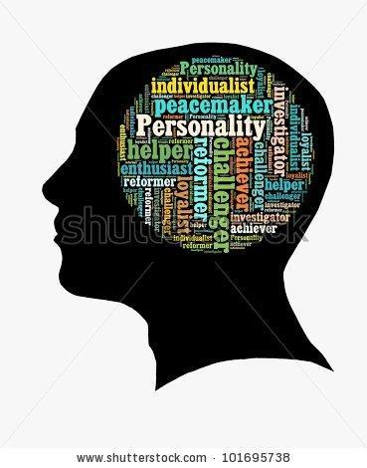

Objective: Your task is to create a personality portfolio that demonstrates your understanding of the many varied personality theories. You can use any digital or non-digital program you wish to put together your portfolio. Follow the steps below and the rubric included CAREFULLY

**Item 1:** *What is your Personality Type*? Include the results of the Myers-Briggs/16 PF and the “Big Five” that are given and write a paragraph explaining your personality type according to the results of each test. Take screenshots of each of your results to prove completion. Do you agree with the findings? If so – why? If not, why

not? These paragraphs should be quality analysis.

● 16 PF: <https://www.16personalities.com/free-personality-test>

● Big Five: <http://www.outofservice.com/bigfive/>

**Item 2**: *Career Quiz - Take the Career Quiz on Xello (log in to xello- click on Matchmaker)*

Take a screenshot of the top careers -what do you think? research and do a write up on two that you pick- does it fit you? Is this something you want to look into at a later date?

**Item 3:** *6 word stories*- **Each 6 word story must have a picture with it**, you can take a picture of yourself, use Google images, draw it, etc. You will need a total of ten 6-word stories- **Label your story with the appropriate heading and to what your story relates to.**

*Psychoanalysis-* Write a 6 word story about the following:

● Something the id would want (keep it school appropriate)

● Your superego

● A defense mechanism you use

*Humanist-*Write a 6 word story for the following:

● Your freshman self

● Your future self (pick any age)

*Trait Perspective-* Write a 6 word story for each bullet point:

● The trait(s) that make you the most proud

● The trait(s) you want to change about yourself

Social-Cognitive Perspective - Write a 6 word story for the following:

● Your “school” personality.

● Your “home” personality.

● Which *Locus of Control* you prescribe to.

**Item 4 *:*** *Personality Masks*

* Design a mask that represents your personality as you see it (you may use our template or create one of your own) you may use words, colors, symbols etc ---- have fun!!

- The front of your mask shows the personality you allow the world to see

The back of the mask is what you show only trusted others or just keep to

Yourself ([Template Pics](https://docs.google.com/document/d/1dKSBi6TbwamOAwgOy_9aPGGIy0L8xuMRVDZOXP2hadQ/edit?usp=sharing))

* You must in some way incorporate 4 personality theories in your mask in some way-
  1. Psychodynamic
  2. Trait
  3. Humanism
  4. Social Cognitive
* Explain your mask in writing:
  1. A description of the personality that the mask represents, including the symbols you have used to represent the different aspects of the personality.
  2. Your reflections on the process of creating the mask, and the outcome (how was it and how happy are you with the mask).
  3. Your comments on perception of personalities, the potential differences between how we see ourselves and how others may see us. How were the slips incorporated?

**Item 5**: *Birth Order Analysis-* Alfred Adler said that birth order has a whole lot to do with who you are and why you act the way that you do. Analyze the birth order traits according to <https://www.parents.com/baby/development/social/birth-order-and-personality/>

and assess whether your personality (as you see it) supports or refutes their birth order analysis. Give specific examples and specific details of why you believe this to be true or false.

**Item 6**: *Personality Islands*- List your personality islands you have today. Create a visual of two of those Personality Islands and an analysis (use Inside Out as an example)

***Attach your rubric to the top of the printed assignment. If submitted digitally, include an electronic copy of rubric into your assignment or submit one solo with your name on it in class.***

|  | ***Expected Content*** | ***Points earned/ Points possible*** |
| --- | --- | --- |
| ***Item 1: Personality Test Reflection*** | Write a one paragraph reflection FOR EACH test you took in class highlighting the results- what you learned, what surprised you, does this match your personality? Make sure to include the results of the Myers-Briggs/16PF and Big 5 results. | ***/20*** |
| ***Item 2: Career Quiz*** | Screenshot and write up about two of the careers. | ***/10*** |
| ***Item 3: 6 Word Stories*** | Ten completed 6 word stories (see page 1 for topics). 6 word stories must have visuals which should be creative and neatly done | ***/25*** |
| ***Item 4: Personality Masks*** | Both sides are completed  There is a written explanation  Creativity and time was used  20 slips are included | ***/25*** |
| ***Item 5: Birth Order*** | Analysis of birth order and your personality | ***/10*** |
| ***Item 6: Personality Islands*** | List of personality islands and Illustration of 2 Personality Islands with analysis of the islands | ***/20*** |
| **Mechanics** | Neatly done with proper spelling and grammar. | ***/5*** |
| **Format/Creativity** | Done in a format that is appropriate for the content and used some creativity for the final product (a PowerPoint or Google presentation is not creative). | ***/5*** |
| **Loss of Points** | No rubric attached  Emailed assignment to teacher to attempt to print  Lack of editing/working on grammar  Emailing with last minute questions |  |
| **Total** | ***this portfolio will count double in your project section:)*** | ***/120*** |

***4***: 105-120 ***3.5***: 90-104 ***3***: 72-89 ***2***: 48-71